A000-**Eur-Germany-Vogelherdhöhle-Figurine-***Panthera leo spelaea***-Mammoth Ivory-Mid. Paleolithic-**40,000 BP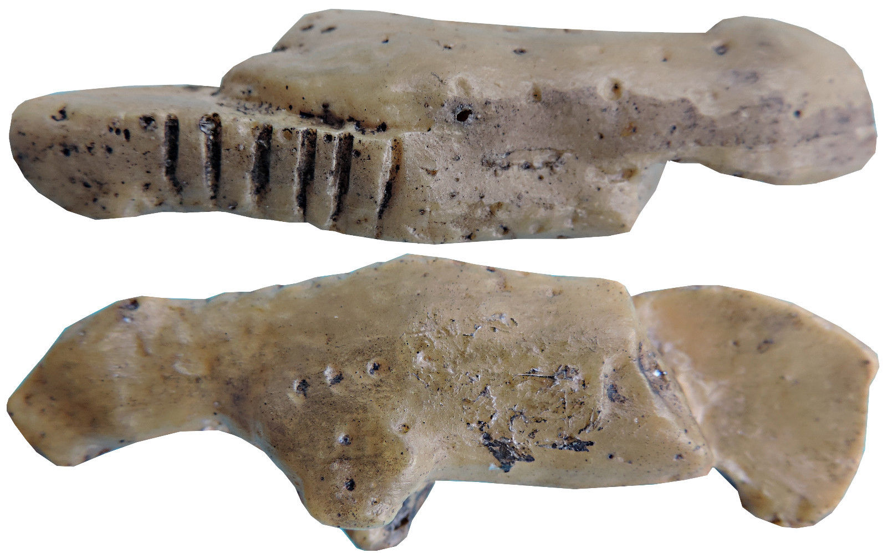

Fig. 1-2. **Germany-Vogelherdhöhle-Layer V-Figurine-***Panthera leo spelaea Anthropomorph* (Eurasian Cave-Lion-Man) **- Mammoth Ivory-Middle Paleolithic-**40,000 BP -29,000 BP, recto and verso, museum replica in resin.

Fig. 3. Same, original, mammoth ivory, recto From Müller-Beck *et alii* 1987.

Fig. 4-6. Germany- Hohlenstein Stadel, 40,000 BP, H 30 cm, photo Y. Mühleis, LAD, from https://www.denkmalpflege-bw.de/fileadmin/_processed_/csm_Loewenmensch_Hohlenstein_af145345ee.png

Case No.: 1

Accession No.:

**Formal Label: Eur-Germany-Vogelherdhöhle-Figurine-***Panthera leo spelaea***-Mammoth Ivory-Mid. Paleolithic-**40,000 BP

**Display description:**

**This ivory** *Panthera leo spelaea* **mammoth-ivory figurine, dating** 40,000 BP-29,000 BP, **exhibits the shape of a lioness with a lioness’s scapulae prominently displayed when she is on the hunt. The hunter who carved theis figurine from mammoth ivory also indicated that he had killed six lionesses by indicating this with notches in the ivory underside. As such this is a trophy figurine.** Vogelherdhöhle (“Bird Heart Cave”) was probably named for its location above the Lone River in its ability for attracting birds and its heart-like structure, since it has three cave chambers like a heart. It is among the most significant German Paleolithic sites. It is located on a sloping limestone ledge 20 m above the Lone River Valley over which it possessed a strategic view for hunters of Pleistocene game.

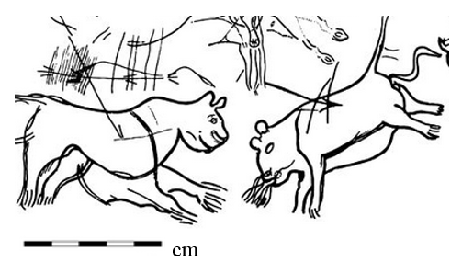

**Fig. Two** *Panthera leo spelaea* dying from arrow wounds*,* Lascaux Cave, Dordogne, France, from Leroi-Gourhan and Allain 1979.

**LC Classification:** GN772.2.A8

**Date or Time Horizon:** 40,000 BP-29,000 BP

**Geographical Area: Vogelherdhöhle Site, Germany**

**Map, GPS Coordinates:** 48.561321, 10.189116

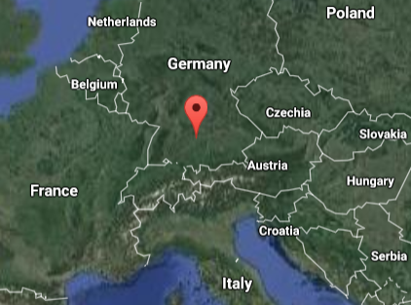

Fig. 2. Location of Vogelherdhöhle in the local landscape.

Fig. 3. Location of Vogelherdhöhle in Germany.

**Cultural Affiliation:** Aurignacian

**Medium:** original, mammoth ivory; museum replica in resin.

**Dimensions: L** 69 mm, D 10.5 mm, W 19 mm  
**Weight:**

**Provenance: University of Tübingen.**

**Condition:** museum replica in resin**.**

**Discussion:**

On 23 May 1931 Hermann Mohn, a private researcher from Heidenheim, while probing the hills near Stetten bei Niederstotzingen for prehistoric remains, found flint artifacts in the rear of a badger den. He informed the prehistory department of the University of Tübingen of a potential Paleolithic cave, which he named ‘Mohnloch’ or Mohn’s hole.’ The Tübingen department sent a junior researcher, Gustav Riek, to Stetten to inspect the site. The Y-shaped cave has three openings (S, SW and N) and covers 170 m2. Mohn and Riek squeezed through the 30 cm x 40 cm opening into the badger den and on the evening of the second day they found the Paleolithic evidence they were looking for: Mohn’s hunch was right, this was confirmed and the site was renamed “Vogelherdhöhle,” “Bird-Heart Cave,” probably because the waters of the Lone River attracted birds in numbers and the cave’s three chambers were shaped like a heart’s. Then, in just three months, Riek had excavated the cave and had dispersed large mounds od ejecta outside the three entrances that were still holding artifacts that had yet to be discovered because of the haste of excavating but now they were without any context. In the intervening years these mounds have been thoroughly re-examined and many artifacts have been recovered.

There are four Middle Paleolithic strata and four Upper Paleolithic strata of Vogelherdhöhle of which two of the latter, layers V and VI belong to the Aurignacian, which are the cultural strata for which Vogelherdhöhle is famous and in which the present artifact was found. The Magdalenian is represented in two layers, the Gravettian is not present at all (as in almost all the cave sites of Lone River Valley) and the Neolithic provides the last evidence of human presence.

Eleven mammoth ivory figurines were excavated by Reik. The lower Aurignacian layer V supplied a total of seven figurines, including a *Panthera leo spelaea* or Eurasian Cave Lion, *Equus ferus przewalskii*, a complete mammoth, parts of a large mammoth (including the neck, femur, and haunches), an unidentified headless animal and an unidentified animal with a head reattached in 2012 (Conard et al., 2013). Four figurines from the upper layer IV include this *Panthera leo spelaea*, a steppe bison, a mammoth and Eurasian Cave Lion-man. Since these layers in which each figurine was excavated is known, it is unfortunate that Riek gave no indication of their exact positions and contexts.

**References:**

Bosinski, G. 2013. “Les precurseurs de l'art aurignacien.” In P. Bodu, L. Chehmana, L Klaric, L. Mevel, S. Soriano and N. Teyssandier, N. (eds.), *Le Paleolithique superieur ancien de /'Europe du Nord-Ouest: Reflexions et syntheses a partir d'un projet collectif de* *récherche sur le centre et le sud du Bassin parisien: Actes du colloque de Sens (15-18 avril 2009)* Paris: Sociéte préhistorique française.

Conard, N. J., Zeidi, M. and Bega, J. 2013. “Die letzte Kampagne *der* Nachgrabungen am Vogelherd,” *Archaologische Ausgrabungen in Baden-Wurttemberg,* 2012: 84-88.

Delporte, H. 1990. *L'image des animaux dans l'art préhistorique,* Paris: Picard.

Delporte, H.. 1993. *L'image de la femme dans l'art préhistorique. Nouvelle edition augmentée,* Paris, Picard.

Hahn, J. 1970. “Die Stellung der mannlichen Elfenbeinstatuette aus dem Höhlenstein-Stadel in der jungpaläolithischen Kunst,” *Germania,* 48: 1-12.

Hahn, J., Muller-Beck, H. and Taute, W. 1985. *Eiszeithöhlen im Lonetal.* Stuttgart: Konrad Theiss Verlag.

Leroi-Gourhan Arl. and Allain J., eds. 1979. *Lascaux inconnu.* Paris: CNRS éditions.

Müller-Beck, H. and Albrecht, G., eds. 1987. *Die Anfänge der Kunst vor 30000 Jahren*. Stuttgart, Theiss.

Niven, Laura. 2006. The Palaeolithic Occupation of Vogelherd Cave: Implications for the Subsistence Behavior of Late Neanderthals and Early Modern Humans. Tübingen: Kerns.

Riek, Gustav. 1934. *Die Eiszeitjägerstation am Vogelherd im Lonetal*, Bd. I: Die Kulturen. Leipzig: Kabitzsch.

Riek, Gustav. 1935. *Kulturbilder aus der Altsteinzeit Württembergs*. Tübingen: Franz F. Heine.